Assignment 7.3 Ai Assisted Coding
NAME:MD.ADIL
Htno:2303a51988
Btno:06

Task 1: Fixing Syntax Errors
Prompt: The following Python function has a syntax error. Identify the issue and correct it. Also explain what the syntax error is.
def add(a, b) return a + b Input: Bug Code:
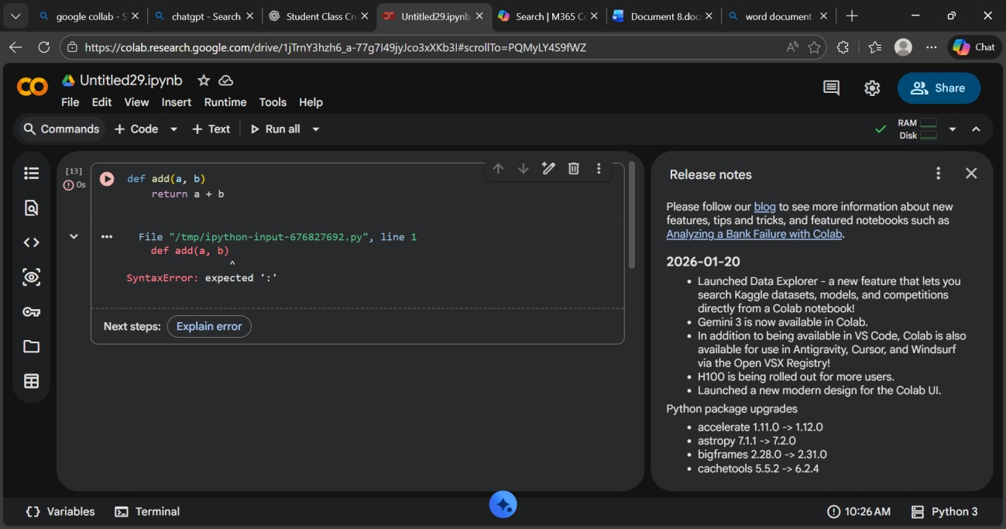
2) corrected code:
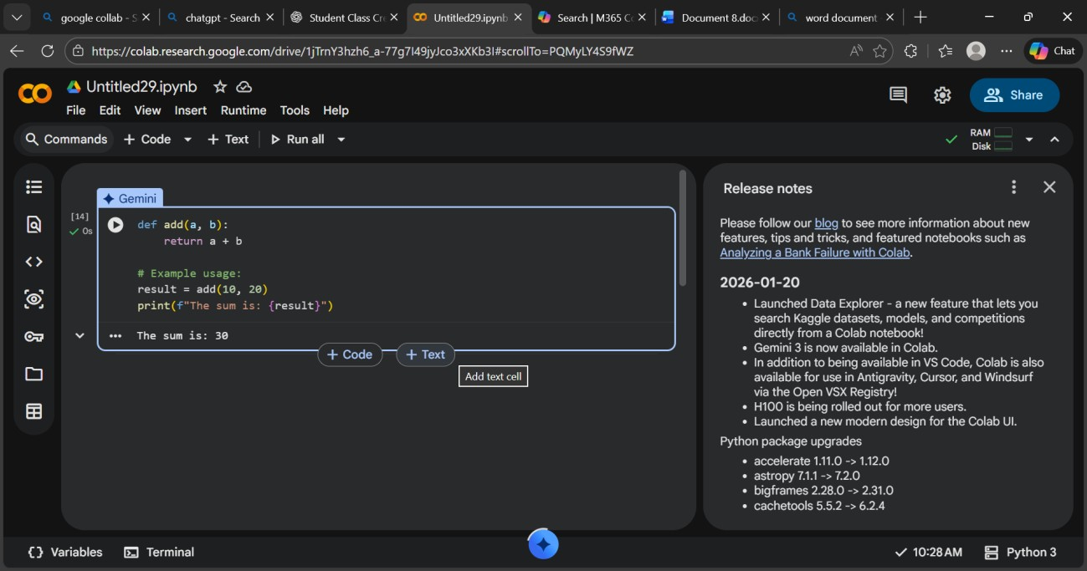
Output:
• 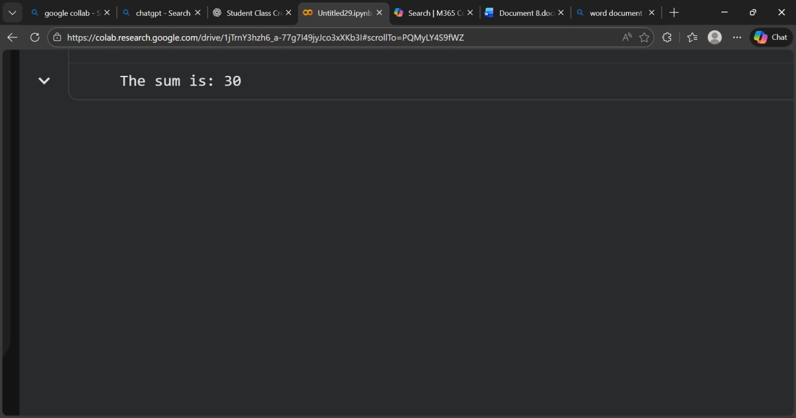
Explanation:
- In Python, a colon : is required after defining a function header.
- Without the colon, Python cannot recognize the start of the function block, causing a SyntaxError.
- AI correctly identified the missing colon and fixed the function definition.

Task 2: Debugging Logic Errors in Loops
Prompt: The following Python loop runs infinitely. Identify the logic error, correct the loop, and explain the issue.
i = 1 while i <= 5:
print(i) i -= 1
Input: Bug code:
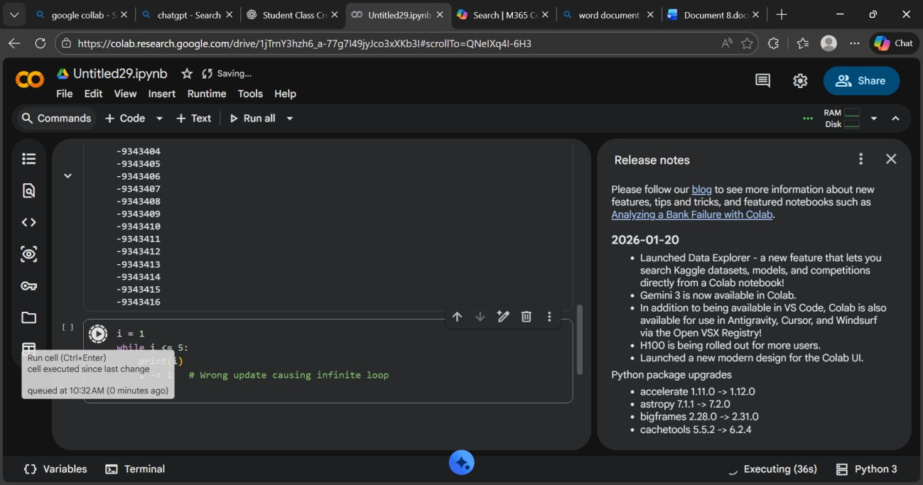
Corrected code:
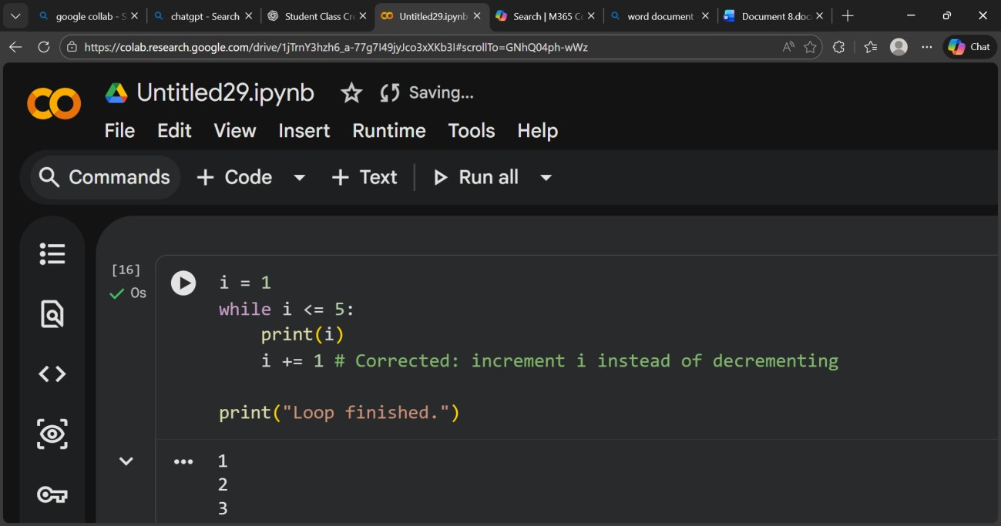
Output:
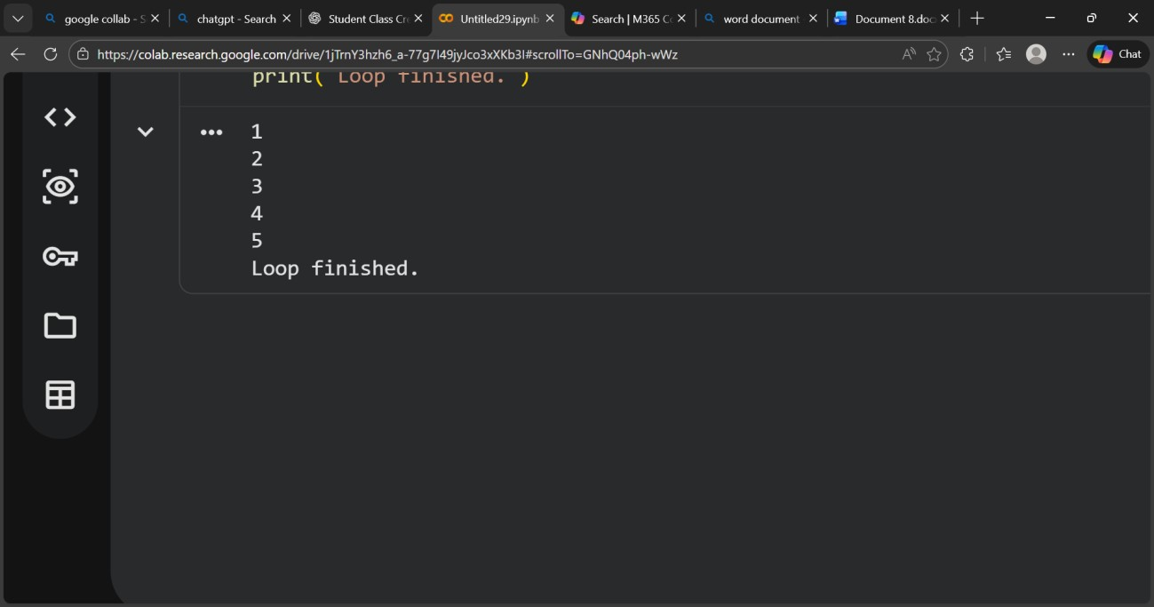
Explantion: The variable i was decreasing (i -= 1) while the condition required it to increase, causing an infinite loop.
Changing it to i += 1 allows the loop to reach the stopping condition and terminate correctly.

Task 3: Handling Runtime Errors (Division by Zero)
Prompt: This Python code causes a runtime error. Identify the problem, fix it using tryexcept, and explain the issue. def divide(a, b): return a / b print(divide(10, 0))
Input:Bug Code
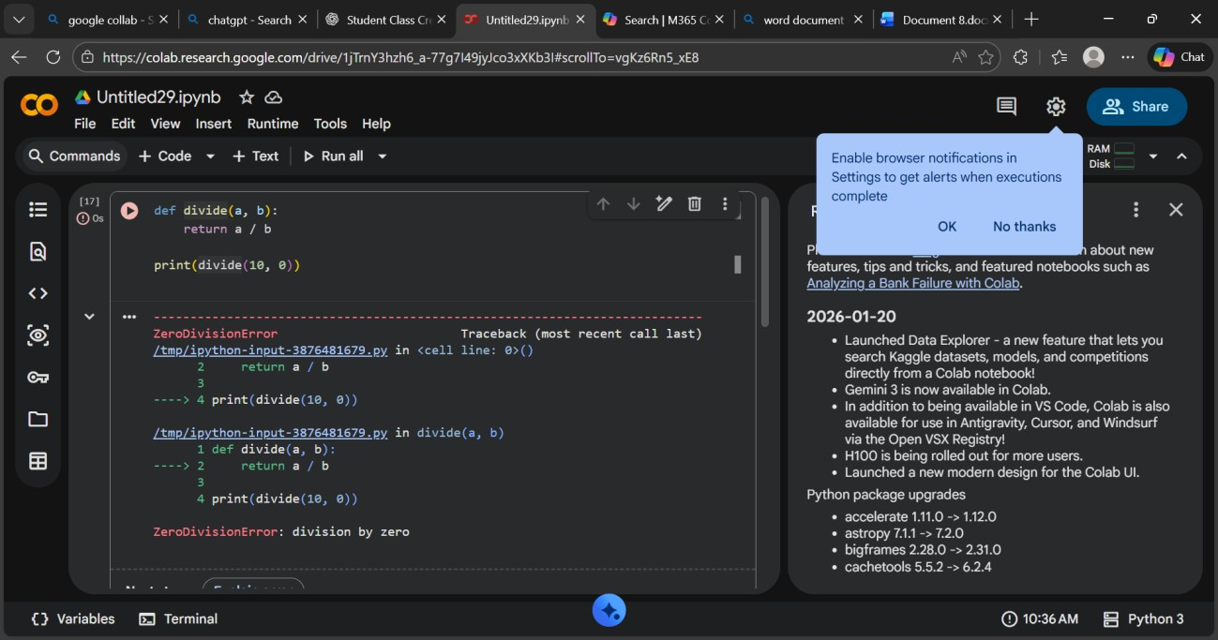
Corrected Code:
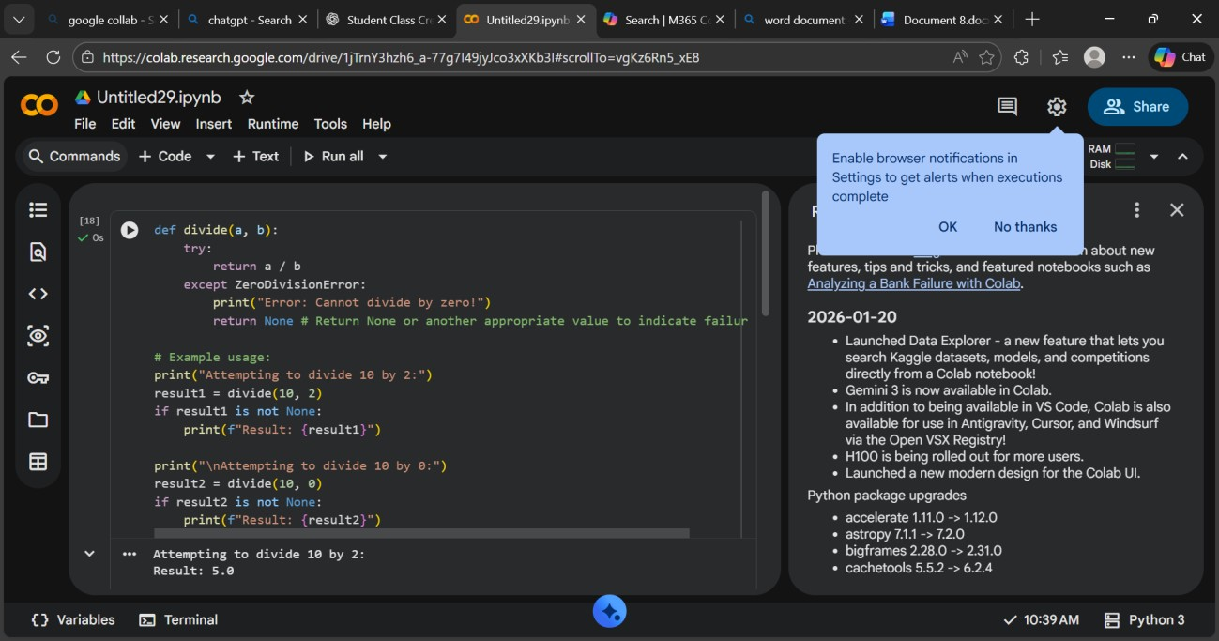
Output:
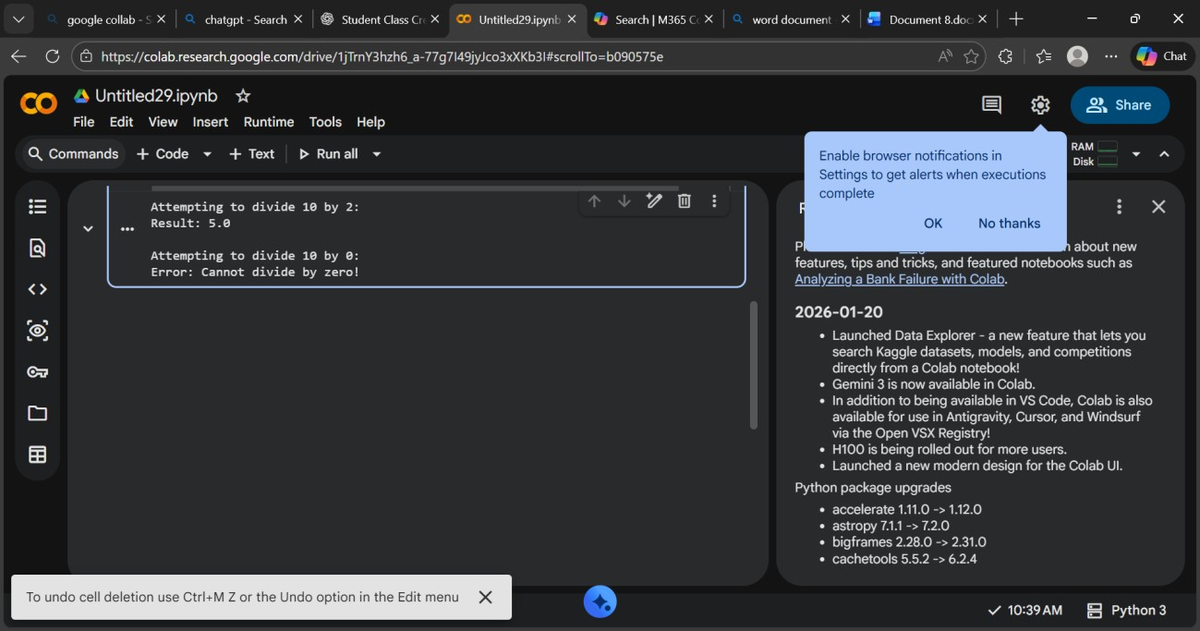
Explanation: he program crashes because division by zero is not allowed in Python, causing a ZeroDivisionError.
Using try-except prevents the crash and safely handles the error.

Task 4: Debugging Class Definition Errors
Prompt: The following Python class has an error in the constructor. Identify the issue, correct the class definition, and explain why the fix is needed.
class Student: def init(name, roll): name = name roll = roll
Input:Bug Code
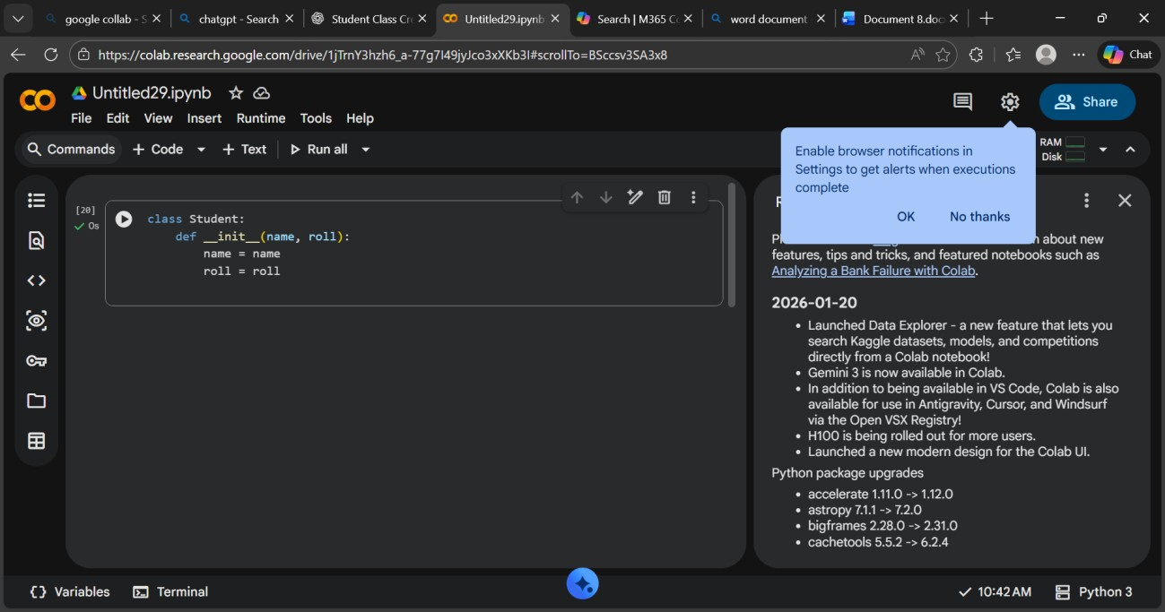
Corrected code:
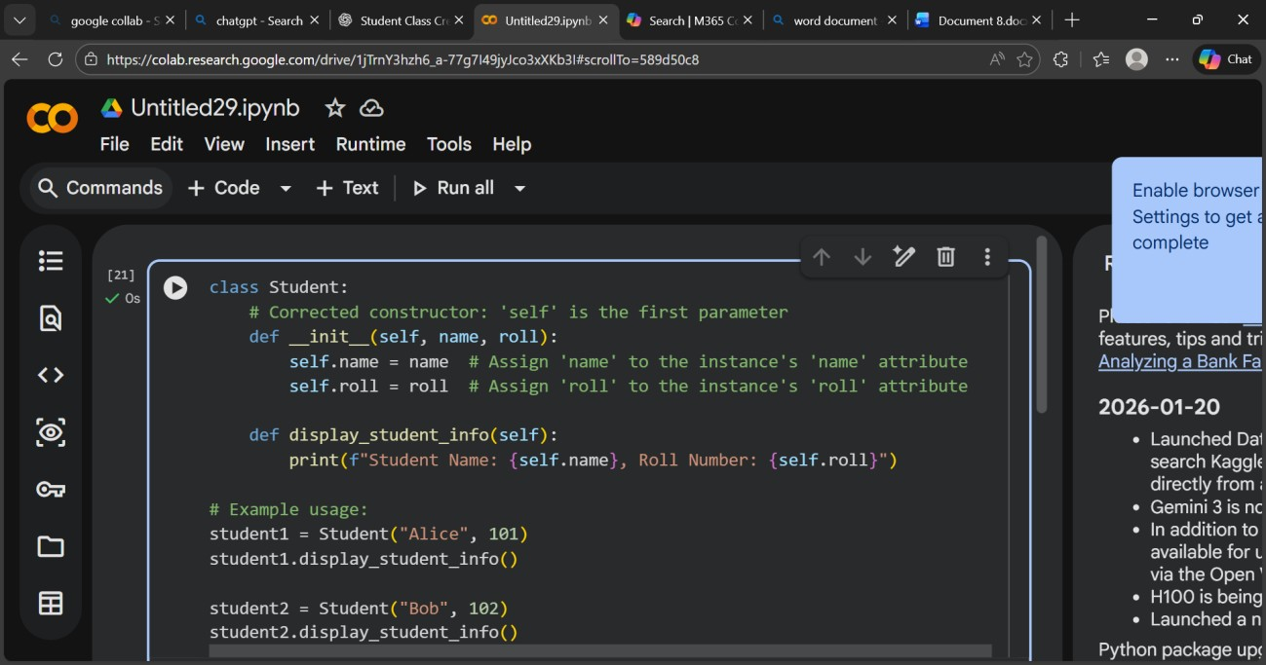
Output:
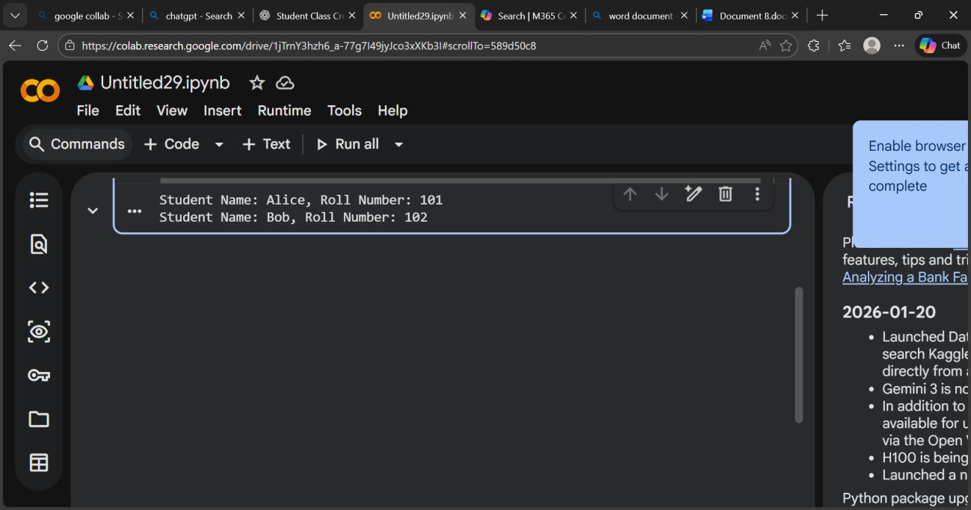
Explanation: The constructor was missing the self parameter, which is required to refer to the object instance.
Using self.name and self.roll stores values inside the object properly. Task 5: Resolving Index Errors in Lists
Prompt: This Python code causes an IndexError. Identify the issue, correct the code using safe access methods, and explain the problem.
numbers = [10, 20, 30]
(numbers[5])
Input:Bug code
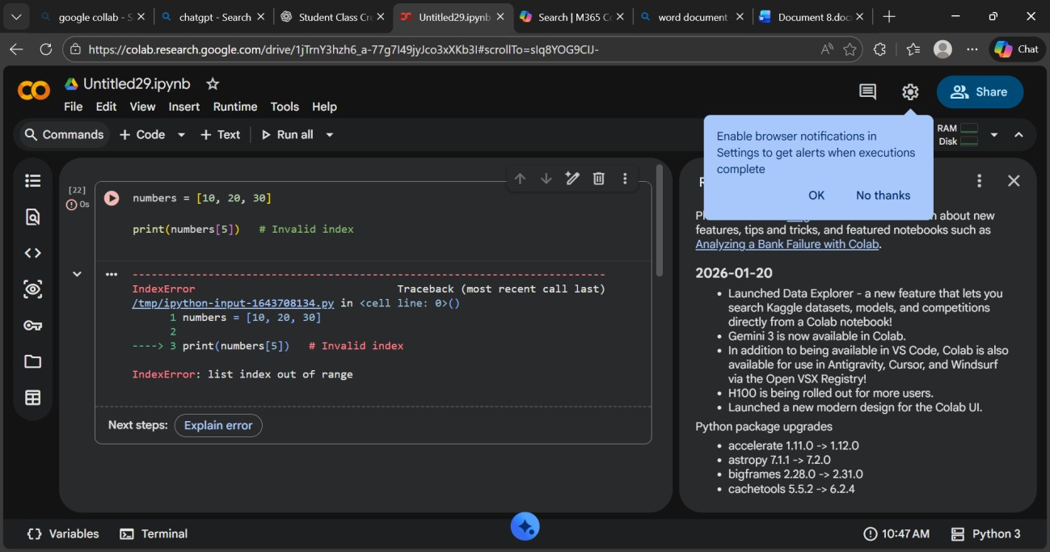
Corrected Code:
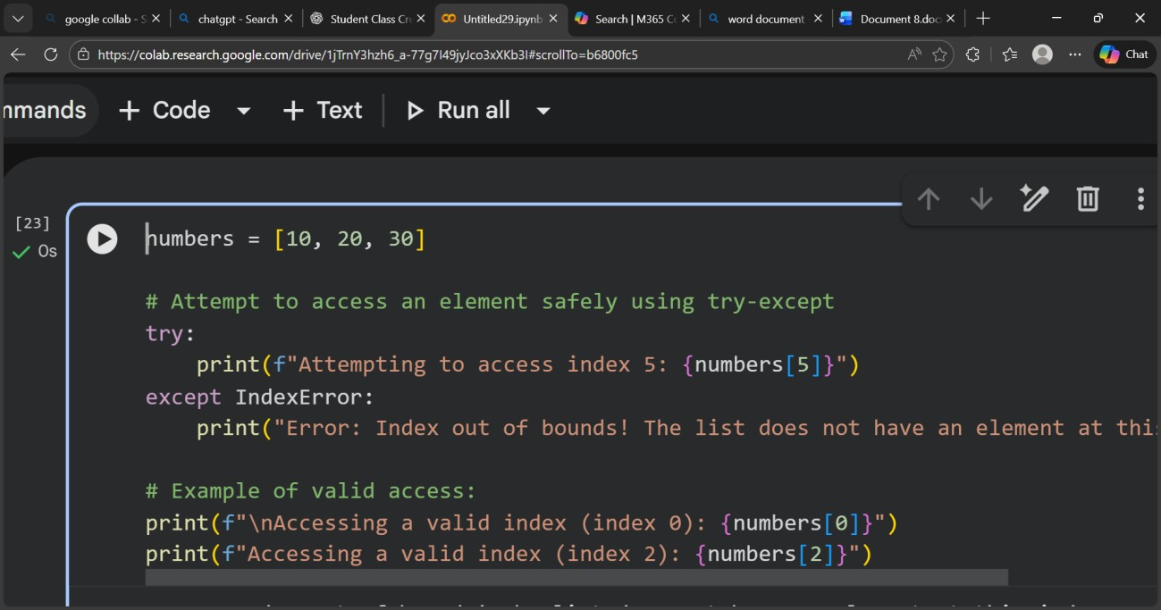
Output:
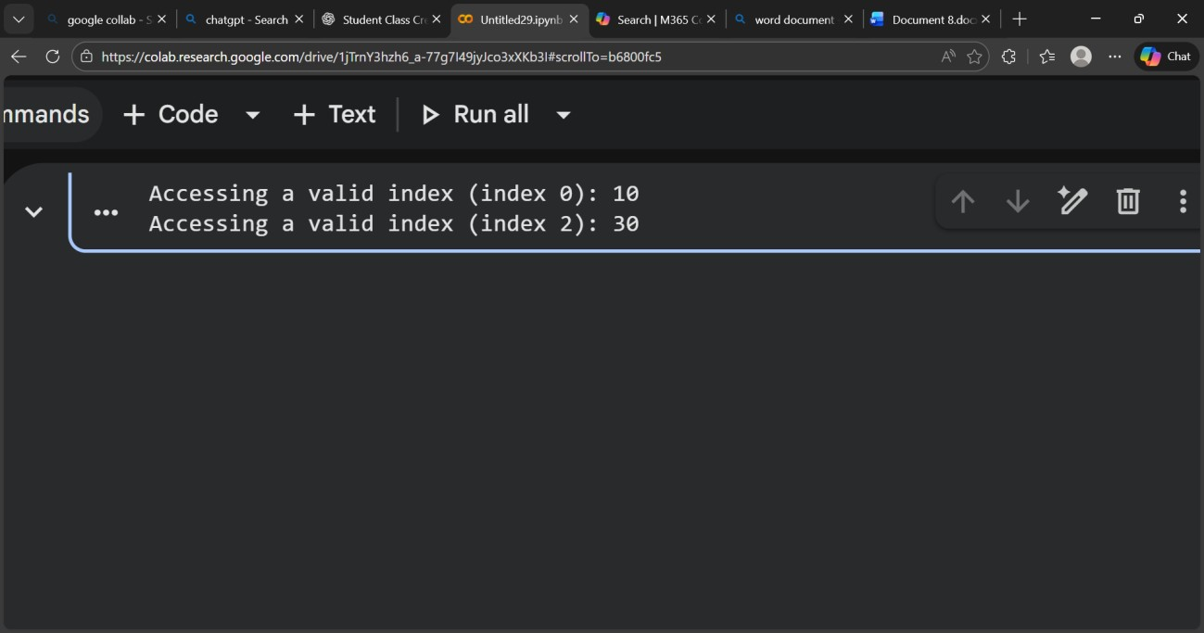
Explanation: The program tried to access an index that does not exist in the list, causing an
IndexError.
Using len() to check bounds prevents the program from crashing.

